Canadian Houses in 1987
Student
April 25, 2018
Table of Contents
Section I: Introduction 1
Section II: Exploratory Data Analysis 2
Univariate Analysis of “price” 2
Univariate Analysis of “lotsize” 5
Univariate Analysis of “bedrooms” 8
Univariate Analysis of “prefer” 9
Bivariate Data Analyses 10
Bivariate Analysis of “price” & “lotsize” 11
Bivariate Analysis of “price” & “bedrooms” 12
Bivariate Analysis of “price” & “prefer” 13
Section III: Simple Linear Regressions 14
Simple Linear Regression of “price” & “lotsize” 14
Simple Linear Regression of “price” & “prefer” 16
Section IV: Multiple Linear Regression 17
Residual Diagnostics 19
Section V: Hypothesis Testing 22
Section VI: Conclusions 23
Honor Code 23

Section I: Introduction
“House Prices in the City of Windsor, Canada” details the prices of houses sold in Windsor, Ontario, Canada in July, August, and September of 1987. The “HousePrices” dataset contains 546 observations on 12 variables. “HousePrices” comes from the “AER” package.
The response variable I will be using is “price”. “price” is a quantitative, continuous variable that lists the sale price of a given house in the dataset. The three explanatory variables I will be using are “lotsize”, “bedrooms”, and “prefer”. “lotsize” is a quantitative variable that measures the lot size of a given property in square feet. “bedrooms” is a qualitative, discrete variable that categorizes houses according to the number of bedrooms each contains. “prefer” is a categorical variable that tells whether or not a given house is located in a preferred neighborhood of the city.
The purpose of this project is to examine the influence that the number of bedrooms, lot size, and location of a house have on its final sale price. Are houses on a larger lot, with more bedrooms, and in a preferred neighborhood more expensive than those on a small lot, with less bedrooms, and in an unpreferred neighborhood? Do any of these three variables individually have a large impact on the final sale prices of these houses? Will this project help explain why today three of the biggest factors advertised in the real estate market are bedroom quantity, lot size, and neighborhood location? In this project, I attempt to answer these questions through univariate and bivariate analyses, simple and multiple linear regressions, and hypothesis testing.

Section II: Exploratory Data Analysis
##Univariate Data Analyses First, I will analyze each variable individually.

Univariate Analysis of “price”
The first analysis will be of the response variable, “price”.
summary(HousePrices$price)
## Min. 1st Qu. Median Mean 3rd Qu. Max.
## 25000 49125 62000 68122 82000 190000
sd(HousePrices$price)
## [1] 26702.67
min(scale(HousePrices$price))
## [1] -1.61488
max(scale(HousePrices$price))
## [1] 4.564278
hist(HousePrices$price, main="House Prices in Windsor, Canada 1987", col="plum2",
xlab="Sale Price of House", ylab="Houses Sold")
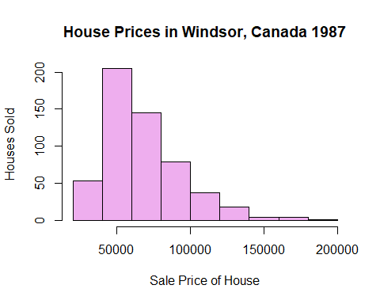
hist(HousePrices$price, main="House Prices in Windsor, Canada 1987", col="plum2",
xlab="Sale Price", ylab="Density", prob=TRUE)
lines(density(HousePrices$price))
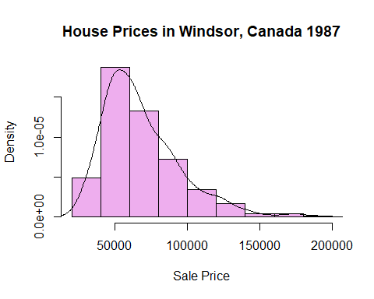
boxplot(HousePrices$price, horizontal=TRUE, main="House Prices in Windsor, Canada 1987",
xlab="Sale Price")
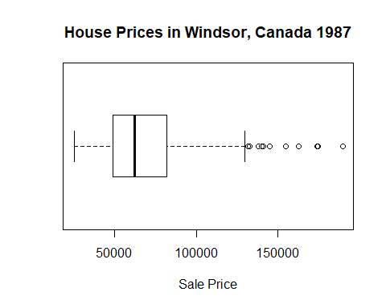
The average price of a house in Windsor, Canada in the late summer of 1987 was $68,121.10. The value that separates the upper and lower prices of houses sold is $62,000. Fifty percent of the houses sold were priced between $49,125 and $82,000. The three cheapest houses sold for $25,000 each. The most expensive house sold for $190,000. The difference between the most expensive and least expensive house is $165,000.
Since “price” is a numerical variable, I will calculate its z-scores. A z-score tells us how many standard deviations away a value is from the mean of the data. Z-scores help us determine which values of the data are extreme or abnormal.
The z-score for the minimum value of the data is -1.61488. Thus, the $25,000 sale price can be considered normal. The z-score for the maximum value of the data is 4.564278. Thus, the $190,000 sale price can be considered an extreme outlier. The six houses priced from $155,000 to $190,000 are considered to be extreme outliers, each with z-scores greater than 3. This means that a normal house in Windsor, Canada from July to September of 1987 was priced between $25,000 and $145,000. Can we conclude that most consumers in the real estate market at this time were on a budget of $145,000 or less?

Univariate Analysis of “lotsize”
Next, I will analyze the first explanatory, independent variable, “lotsize”.
summary(HousePrices$lotsize)
## Min. 1st Qu. Median Mean 3rd Qu. Max.
## 1650 3600 4600 5150 6360 16200
sd(HousePrices$lotsize)
## [1] 2168.159
min(scale(HousePrices$lotsize))
## [1] -1.614395
max(scale(HousePrices$lotsize))
## [1] 5.096368
hist(HousePrices$lotsize, main="Lot Sizes of Houses Sold in Windsor, Canada 1987",
col="plum3", xlab="Lot Size of Property in Square Feet ", ylab="Properties Sold")
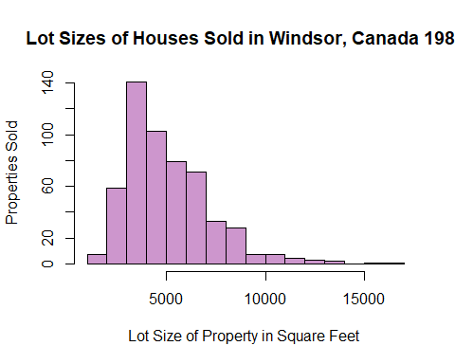
hist(HousePrices$lotsize, main="Lot Sizes of Houses Sold in Windsor, Canada 1987",
col="plum3", xlab="Lot Size of Property in Square Feet ", ylab="Density",prob=TRUE)
lines(density(HousePrices$lotsize))
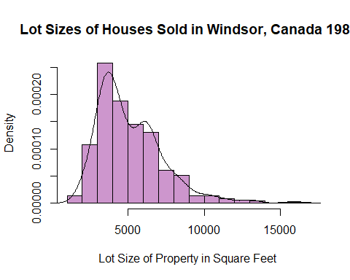
boxplot(HousePrices$lotsize, main="Lot Sizes of Houses Sold in Windsor, Canada 1987",
xlab="Lot Size of Property in Square Feet ", labels=TRUE, horizontal=TRUE)
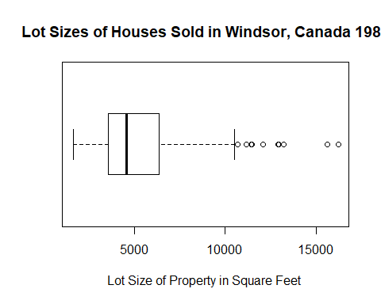
The average lot size of a property sold was approximately 5150 square feet. The value that separates the upper and lower lot sizes of houses sold is 4,600 square feet. Fifty percent of the houses sold were on properties between 3,600 and 6,360 square feet. The smallest property measured 1,650 square feet. The largest property measured 16,200 square feet. The range between the largest and smallest value is 14,550 square feet.
Since “lotsize” is also a quantitative variable, I will calculate the z-scores for its data.
The z-score for the minimum value of the data is -1.614395, which concludes that 1,650 square feet constitutes a normal lot size. The z-score for the maximum value of the data is 5.096368, which signifies that a lot size of 16,200 square feet was an extreme abnormality in Windsor, Canada in the late summer of 1987. The seven houses on lots of 12,090 square feet to 16,200 square feet are each considered to be extreme outliers with z-scores greater than 3. This means that a normal house in Windsor, Canada from July to September of 1987 was on a lot that was between 1,650 and 11,460 square feet. Was having a large amount of land a popular preference for homeowners during this time? From the large range of lot sizes, we might guess that these homeowners potentially could have been farmers, ranchers, gardeners, etc. We may also assume that neighborhoods were not as crowded in 1987 as they are today in 2018, and thus many homeowners’ houses were built on large lots of land.

Univariate Analysis of “bedrooms”
Next, I will analyze the second explanatory, independent variable, “bedrooms”.
table(HousePrices$bedrooms)
##
## 1 2 3 4 5 6
## 2 136 301 95 10 2
prop.table(table(HousePrices$bedrooms))
##
## 1 2 3 4 5 6
## 0.003663004 0.249084249 0.551282051 0.173992674 0.018315018 0.003663004
0.551282051+0.249084249+0.003663004
## [1] 0.8040293
barplot(table(HousePrices$bedrooms), main="Number of Bedrooms in Houses Sold in Windsor, Canada 1987", xlab="Number of Bedrooms", ylab="Houses Sold", col="orchid3")
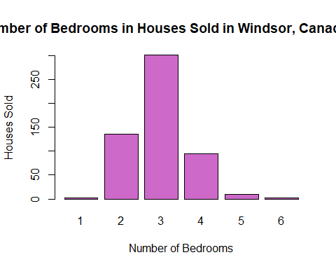
Most of the houses sold (55%) had three bedrooms. 80% of the houses sold had three bedrooms or less.

Univariate Analysis of “prefer”
Finally, I will analyze the third explanatory, independent variable “prefer”.
table(HousePrices$prefer)
##
## no yes
## 418 128
prop.table(table(HousePrices$prefer))
##
## no yes
## 0.7655678 0.2344322
barplot(table(HousePrices$prefer), main="Location of Houses Sold in Windsor, Canada 1987", xlab="Preferred Neighborhood",ylab="Houses Sold", col="orchid4")
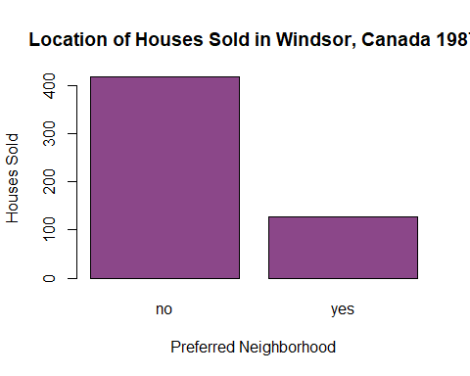
Only 23% of the houses sold in Windsor, Canada in mid 1987 were located in a preferred neighborhood of the city. This means that most of the houses sold (77%) were located in an unpreferred neighborhood. What constituted a neighborhood as preferable during this time? Were crime rates lower in these designated preferred neighborhoods? Did the neighborhoods have access to certain amenities such as pools, parks, or tennis courts? Were neighborhoods considered preferred due to the area’s assigned school and school district?

Bivariate Data Analyses
Now, I will examine the relationships between the response variable, “price” and the three independent variables, “lotsize”,“bedrooms”, and “prefer”.

Bivariate Analysis of “price” & “lotsize”
The first bivariate analysis will examine the relationship between “price” and “lotsize”.
cor(HousePrices$lotsize,HousePrices$price)
## [1] 0.5357957
mean(HousePrices$price)
## [1] 68121.6
mean(HousePrices$lotsize)
## [1] 5150.266
plot(HousePrices$price~HousePrices$lotsize,
main="Relationship Between Lot Size and Price\n of Houses Sold in Windsor, Canada 1987",
col="purple2", xlab="Lot Size in Square Feet", ylab="Sale Price")
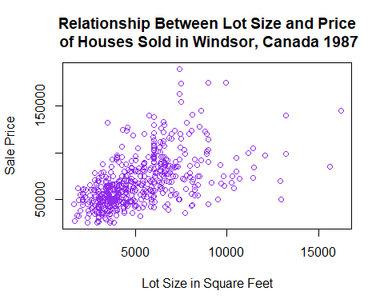
There is a strong, positive relationship between the lot size of a house and its final sale price. Typically, as the lot size of a house increases, the sale price also increases. The most expensive houses sold were on lots larger than the average size of 5,150 square feet. The least expensive houses sold were on lots smaller than the average size of 5,150 square feet. Thus, we can conclude that the lot size of a house influenced its final sale price.

Bivariate Analysis of “price” & “bedrooms”
Next, I will analyze the relationship between “price” and “bedrooms”.
tapply(HousePrices$price, HousePrices$bedrooms, mean)
## 1 2 3 4 5 6
## 38750.00 51886.03 70817.25 81853.68 83140.00 68450.00
plot(HousePrices$price~factor(HousePrices$bedrooms), border="purple3",
xlab="Number of Bedrooms", ylab="Sale Price", main="Relationship Between Number of Bedrooms \nand Price of Houses Sold in Windsor, Canada 1987")
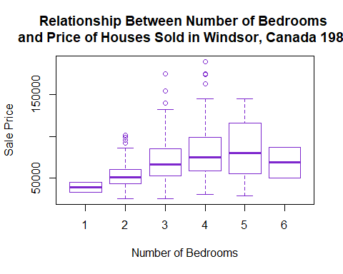
There is a positive relationship between the number of bedrooms in a house and its sale price. The number of bedrooms in a house did have an effect on its final sale price. Disregarding the two houses with six bedrooms, we can see that as the number of bedrooms in a house increases, the bold purple line representing the average sale price of a house with the given number of bedrooms gradually rises.
In regards to the houses with six bedrooms, did the size of the bedrooms impact the final sale price of the house? Were the six bedrooms in the particular two houses much smaller than the four bedrooms in the most expensive house? What matters most: the quantity of bedrooms or the sizes thereof?

Bivariate Analysis of “price” & “prefer”
Finally, I will inspect the relationship between the neighborhood location of a house and its final sale price.
tapply(HousePrices$price, HousePrices$prefer, mean)
## no yes
## 63263.49 83986.37
plot(HousePrices$price~factor(HousePrices$prefer), border="purple4",
xlab="Preferred Neighborhood Location", ylab="Sale Price", main="Relationship Between Location \nand Price of Houses Sold in Windsor, Canada 1987")
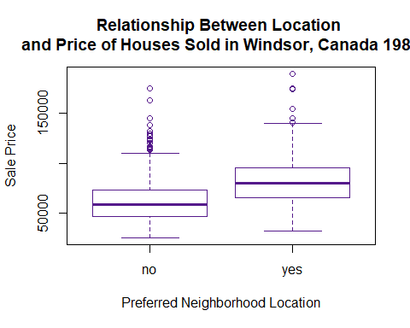
There is a positive relationship between the location of a house and its final sale price. We see that the bold, purple line that represents the mean price of a house in a specified location is higher for houses in the “yes” category than for those located in the “no” category.
The average price of a house located in an unpreferred neighborhood in Windsor, Canada was approximately $63,264.The average price of a house located in a preferred neighborhood of the city was approximately $83,986. The most expensive house was located in a preferred neighborhood, while the cheapest houses were located in unpreferred neighborhoods. This explains the results of the univariate analysis of “prefer”. What was the typical budget of a potential homeowner in Windsor, Canada in 1987? Can it be concluded that buyers were willing to sacrifice neighborhood preference to stay within their budgets?

Section III: Simple Linear Regressions
Now, I will conduct two simple linear regressions that predict the relationship between the response variable and two different explanatory variables.

Simple Linear Regression of “price” & “lotsize”
First, I will run a simple linear regression that predicts the relationship between the lot size of a house and its final sale price.
summary(lm(HousePrices$price~HousePrices$lotsize))
##
## Call:
## lm(formula = HousePrices$price ~ HousePrices$lotsize)
##
## Residuals:
## Min 1Q Median 3Q Max
## -69551 -14626 -2858 9752 106901
##
## Coefficients:
## Estimate Std. Error t value Pr(>|t|)
## (Intercept) 3.414e+04 2.491e+03 13.7 <2e-16 ***
## HousePrices$lotsize 6.599e+00 4.458e-01 14.8 <2e-16 ***
## ---
## Signif. codes: 0 '***' 0.001 '**' 0.01 '*' 0.05 '.' 0.1 ' ' 1
##
## Residual standard error: 22570 on 544 degrees of freedom
## Multiple R-squared: 0.2871, Adjusted R-squared: 0.2858
## F-statistic: 219.1 on 1 and 544 DF, p-value: < 2.2e-16
plot(HousePrices$price~HousePrices$lotsize,
main="Relationship Between Lot Size and Price\n of Houses Sold in Windsor, Canada 1987", col="purple 2", xlab="Lot Size in Square Feet", ylab="Sale Price")
abline(lm(HousePrices$price~HousePrices$lotsize), lwd=3, col="darkblue")
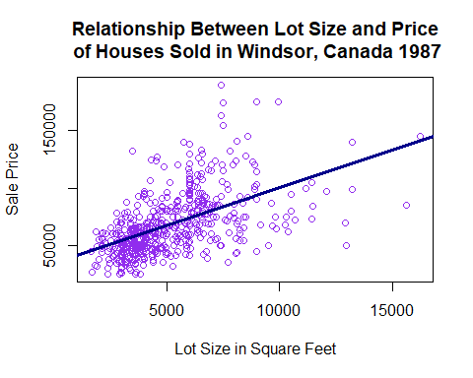
summary(lm(HousePrices$price~HousePrices$lotsize))
##
## Call:
## lm(formula = HousePrices$price ~ HousePrices$lotsize)
##
## Residuals:
## Min 1Q Median 3Q Max
## -69551 -14626 -2858 9752 106901
##
## Coefficients:
## Estimate Std. Error t value Pr(>|t|)
## (Intercept) 3.414e+04 2.491e+03 13.7 <2e-16 ***
## HousePrices$lotsize 6.599e+00 4.458e-01 14.8 <2e-16 ***
## ---
## Signif. codes: 0 '***' 0.001 '**' 0.01 '*' 0.05 '.' 0.1 ' ' 1
##
## Residual standard error: 22570 on 544 degrees of freedom
## Multiple R-squared: 0.2871, Adjusted R-squared: 0.2858
## F-statistic: 219.1 on 1 and 544 DF, p-value: < 2.2e-16
The fitted line shown on the scatter plot displays the best estimated regression line relating a house’s lot size to its price. The slope of this predictive equation is 6.599 This denotes that for each square foot increase in lot size, the predicted sale price of the house increases by approximately $6.60.
The proportion of variation in the final sale price of a house explained by its lot size is 0.2871. Additionally, the residual standard error of this regression is 22,570. This indicates that this model has little predictive power and is not very accurate. It makes sense that this model has little predictive power. When house hunting, do homeowners look solely for a house on a large lot and ignore all other factors? Lot size on its own is not a strong predictor of house price.

Simple Linear Regression of “price” & “prefer”
I will run a simple linear regression that predicts the relationship between the location of a house and its final sale price.
tapply(HousePrices$price, HousePrices$prefer, mean)
## no yes
## 63263.49 83986.37
boxplot(HousePrices$price~HousePrices$prefer, border="purple4", xlab="Preferred Neighborhood Location", ylab="Sale Price", main="Relationship Between Location \nand Price of Houses Sold in Windsor, Canada 1987")
abline(h=63263.49, col="deeppink1", lwd=3)
abline(h=83986.37, col="turquoise2", lwd=3)
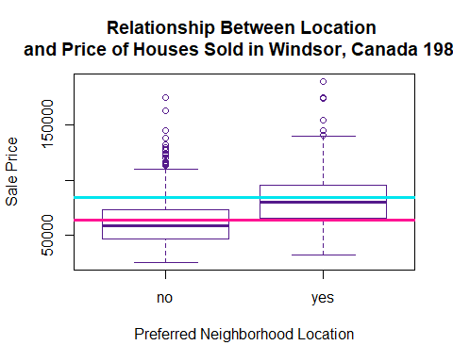
summary(lm(HousePrices$price~factor(HousePrices$prefer)))
##
## Call:
## lm(formula = HousePrices$price ~ factor(HousePrices$prefer))
##
## Residuals:
## Min 1Q Median 3Q Max
## -52086 -17263 -4486 10664 111737
##
## Coefficients:
## Estimate Std. Error t value Pr(>|t|)
## (Intercept) 63264 1234 51.248 < 2e-16 ***
## factor(HousePrices$prefer)yes 20723 2550 8.128 2.96e-15 ***
## ---
## Signif. codes: 0 '***' 0.001 '**' 0.01 '*' 0.05 '.' 0.1 ' ' 1
##
## Residual standard error: 25240 on 544 degrees of freedom
## Multiple R-squared: 0.1083, Adjusted R-squared: 0.1067
## F-statistic: 66.06 on 1 and 544 DF, p-value: 2.959e-15
Since “prefer” is a categorical variable, the interpretation of the coefficients of this regression is different than the previous regression. The “intercept” or “baseline” of this regression represents the predicted price of houses that are located in an unpreferred neighborhood. The number “20,723” indicates the amount of increase in dollars from the baseline value of houses that are in a preferred neighborhood in Windsor, Canada. Thus, the estimated average price of a house located in an unpreferred neighborhood is $63,264 as represented by the pink line. The estimated average price of a house located in a preferred neighborhood is $83,987 as illustrated by the blue line.
From the plot, it is obvious that the blue line is above the pink line, which affirms the previous conclusion that neighborhood location positively influences final sale price.
The proportion of variation in final sale price of a house explained by its neighborhood location is 0.1083. Additionally, the residual standard error of this regression is 25,240. This indicates that this model has very little predictive power and is not very accurate. It is logical that this model has little predictive power. Neighborhood location may be a starting point for some house hunters, but it is certainly not the only determinant of purchase. Preferred neighborhood location on its own is not a strong predictor of house price.

Section IV: Multiple Linear Regression
Next, I will run multiple linear regressions that predict the price of a house sold based on a combination of the explanatory variables. In both regressions, I will use lot size as an explanatory variable, since it had the highest R-squared value as a simple linear regression. I will also use “prefer” in each regression for simplicity. I will first run a regression relating “price” to “lotsize” and “prefer”. Then, I will run a similar regression, this time doing a log transformation of “price”, since it is an economic variable. In conclusion, I will interpret which model I believe is the most telling.
summary(lm(HousePrices$price~HousePrices$lotsize+factor(HousePrices$prefer)))
##
## Call:
## lm(formula = HousePrices$price ~ HousePrices$lotsize + factor(HousePrices$prefer))
##
## Residuals:
## Min 1Q Median 3Q Max
## -61526 -13982 -4129 9894 97941
##
## Coefficients:
## Estimate Std. Error t value Pr(>|t|)
## (Intercept) 3.416e+04 2.416e+03 14.143 < 2e-16 ***
## HousePrices$lotsize 5.977e+00 4.448e-01 13.437 < 2e-16 ***
## factor(HousePrices$prefer)yes 1.355e+04 2.274e+03 5.957 4.62e-09 ***
## ---
## Signif. codes: 0 '***' 0.001 '**' 0.01 '*' 0.05 '.' 0.1 ' ' 1
##
## Residual standard error: 21880 on 543 degrees of freedom
## Multiple R-squared: 0.3308, Adjusted R-squared: 0.3283
## F-statistic: 134.2 on 2 and 543 DF, p-value: < 2.2e-16
summary(lm(log(HousePrices$price)~HousePrices$lotsize+factor(HousePrices$prefer)))
##
## Call:
## lm(formula = log(HousePrices$price) ~ HousePrices$lotsize + factor(HousePrices$prefer))
##
## Residuals:
## Min 1Q Median 3Q Max
## -0.85198 -0.19271 -0.01664 0.19514 0.91656
##
## Coefficients:
## Estimate Std. Error t value Pr(>|t|)
## (Intercept) 1.058e+01 3.336e-02 317.139 < 2e-16 ***
## HousePrices$lotsize 8.410e-05 6.142e-06 13.692 < 2e-16 ***
## factor(HousePrices$prefer)yes 1.970e-01 3.141e-02 6.271 7.31e-10 ***
## ---
## Signif. codes: 0 '***' 0.001 '**' 0.01 '*' 0.05 '.' 0.1 ' ' 1
##
## Residual standard error: 0.3022 on 543 degrees of freedom
## Multiple R-squared: 0.3424, Adjusted R-squared: 0.34
## F-statistic: 141.4 on 2 and 543 DF, p-value: < 2.2e-16
exp(1.058e+01)
## [1] 39340.11
exp(8.410e-05)
## [1] 1.000084
exp(1.970e-01+1.058e+01)
## [1] 47906.19
47906.19-39340.11
## [1] 8566.08
I will interpret the second model. As we can see, the proportion of variation in “price” as told by “lotsize” and “prefer” is increased after performing a log transformation of “price”.
To correctly interpret the coefficients of a log transformation, we use the “exp” function.
The baseline of this model corresponds to the houses that are not located in a preferred neighborhood and its coefficient is equivalent to $39340.11.
Holding lot size constant, for the alternate group “yes”, there would be an $8566.08 increase from the price of a house in the “no” category.
Holding neighborhood location constant, an increase in one square foot of lot size results in a $1 increase in price.
The null hypothesis pertaining to “lotsize” states that there is no relationship between “lotsize” and “price”. The null hypothesis regarding “prefer” states that there is no relationship between “prefer” and “price”. The alternative hypotheses each state that there is some relationship between the response variable and the individual explanatory variables. Mathematically, the null hypotheses and their corresponding alternative hypotheses state that:
H0: Beta1=0 & H1: Beta1≠0
H0: Beta2=0 & H2: Beta2≠0
where Beta1 represents the slope of “lotsize” and Beta2 represents the coefficients of “prefer”.
The variable “lotsize” is significant at the 0.05 level, meaning that there is a linear relationship between “price” and “lotsize”. Both the “no” and “yes” groups for the variable “prefer” are significant at the 0.05 level. We can conclude that there is a linear relationship between “price” and “prefer”. Based on this information, we can reject each null hypothesis.

Residual Diagnostics
plot(lm(log(HousePrices$price)~HousePrices$lotsize+factor(HousePrices$prefer)),
col="darkorchid4")
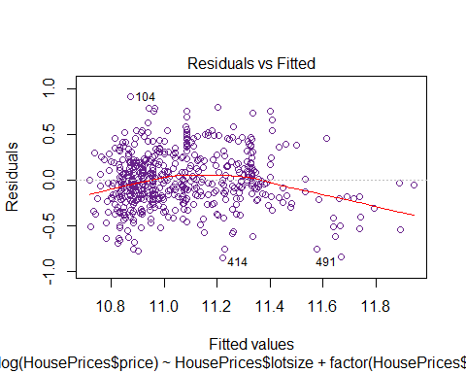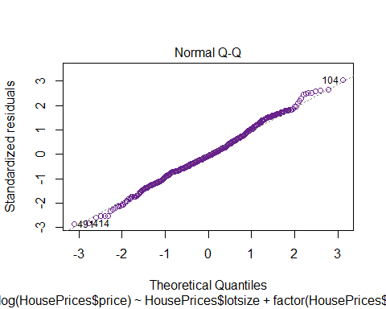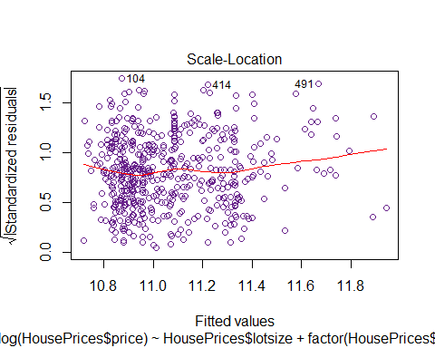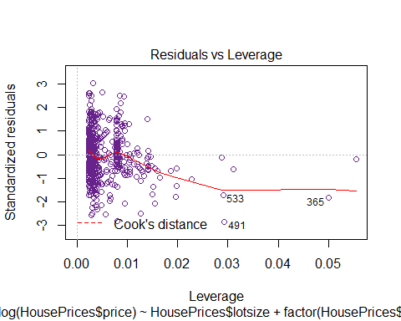
In the Residuals vs Fitted plot, we are testing for linearity. If the plot shows no pattern, then we can confirm that there is a linear relationship between the response variables and the explanatory variables. In this plot, we see that the data is clustered toward the left. From this depiction, it seems likely that the linearity assumption is not met.
In the Normal Q-Q plot, we are testing for normality. If the plot shows a seemingly straight line, then we can conclude that the data is normally distributed. Since the generated plot seems to follow a straight line with no severe deviations, we can conclude that our data is normal.
In the Scale-Location plot, we are checking for constant variance. Similar to the first plot, if the third plot shows no pattern, we can surmise that there is constant variance. The residuals in our plot seem randomly spread out. There does not seem to be an apparent pattern in this plot. We can speculate that the constant variance assumption is met.

Section V: Hypothesis Testing
Finally, I will complete a formal test of hypothesis comparing my response variable “price” to the categorical predictor “prefer”.
t.test(HousePrices$price~HousePrices$prefer)
##
## Welch Two Sample t-test
##
## data: HousePrices$price by HousePrices$prefer
## t = -7.4784, df = 187.27, p-value = 2.821e-12
## alternative hypothesis: true difference in means is not equal to 0
## 95 percent confidence interval:
## -26189.34 -15256.42
## sample estimates:
## mean in group no mean in group yes
## 63263.49 83986.37
In this t-test, the null hypothesis states that the mean price of a house that is located in a preferred neighborhood is equal to the mean price of a house that is not located in a preferred neighborhood. Mathematically:
H0: mu(preferred) = mu(not preferred)
The alternative hypothesis states that the mean price of a house that is located in a preferred neighborhood is not equal to the mean price of a house that is not located in a preferred neighborhood. Mathematically:
H1: mu(preferred) ≠ mu(not preferred)
The null hypothesis can be rejected, since the p-value of the t-test is 2.821e-12, which is less than 5%. Thus it can be concluded that there is a statistically significant difference between the means of the two groups.
The 95% confidence interval for the difference in means is approximately (-26,189, -15,256). This means we can be 95% confident that the difference in mean prices of houses based on their neighborhood location is between $26,189 and $15,256.

Section VI: Conclusions
We can conclude that all three explanatory variables have a relationship to the response variable. The square footage, bedroom quantity, and neighborhood location of houses in the market affected their final sale price. We found that, typically, the most expensive houses were located in preferred neighborhoods on relatively large lots and had at least three bedrooms or more. The least expensive houses were each located in unpreferred areas on smaller lots and had less than three bedrooms.
We found that these variables as individuals do not have a significant effect on the price of a house. Together, however, the power of our predictive model increased. This is logical, since future homeowners are influenced by each of these factors and are unlikely to base their purchases on a single characteristic of a house.
This project does raise questions about consumers in this market during this particular time. How large were their families? Were larger families more inclined to purchase houses with a greater number of bedrooms, or were they willing to share rooms? What was their budget? Did it affect their willingness to sacrifice certain desired characteristics of a house? Was neighborhood location important due to the crime rate in the area? Was there a certain school that parents wanted their children to attend, and thus their final decision was heavily influenced by neighborhood location? Was farming or ranching a popular occupation, and thus houses were built on larger lots?
Would this project have produced different results if the data detailed information from a different city during a different time? Would any of the variables be more revealing on their own? For instance, what results would we expect to see from Detroit, Houston, Sacramento, or Atlanta in 2000, 2008, or 2017?
I believe that this project would have been more telling if background research was completed pertaining to Windsor, Canada in 1987.
Overall, this project was successful in explaining the relationships between a house’s final sale price, and its three most important features: lot size, bedroom quantity, and neighborhood location. In a real world application, this project helps to better understand the basics behind the real estate market and its advertising.

Honor Code
On my honor, I have neither given nor received any unauthorized assistance on this work. Student

